Daniel 10

* **Why Baltishazar –** maybe because it was in that zechus that he was notified, maybe that is the connectin to lechem chamudos in Daniel’s mind, that he wanted to be given understanding
* **3 7s**
  + Rashi years, from when the Beis Hamikdash was cancelled
  + RSG & Ibn Ezra – days
  + What about karbanos and Pesach wine? Ibn Ezra – not Nissan, see Rosh Hashana about the next Coresh; Maybe like Rashi where it was years, for mitzvos is different
  + Maybe according to Rashi he was following the ideas of the cycle (comment about Helene 21 years nazir)
* Bin Bamarah – Hashem showed him and told the angel to explain but even with all that it is not absolute – Ki yom nakam bilibi
* **Chidekel**
  + Why is it called the big river?
  + Yalkut Shimoni – Larger than Uval or chosen of river
  + First vision was by the Ocean to suggest chaos and turbulence, second by Uval to suggest succession from Persia. Maybe here to suggest connection
  + Ibn Ezra compares to Yechezkail, see Malbim that explains that he wasn’t prepared or preparing for a prophecy  
    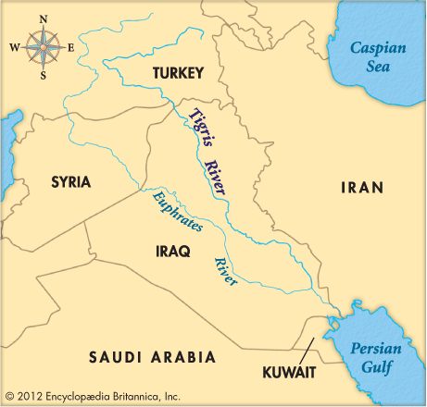 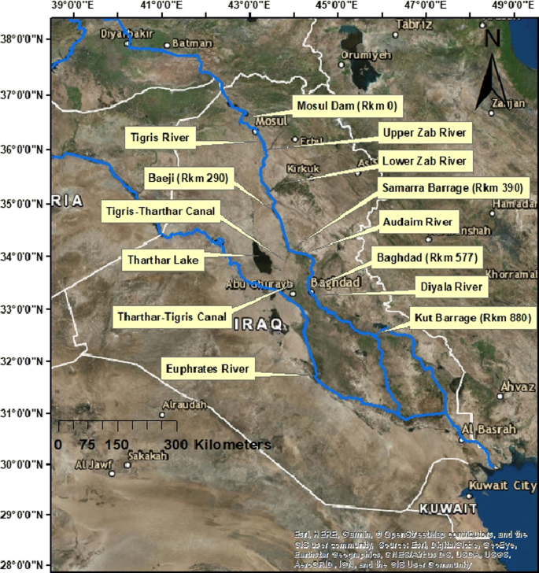

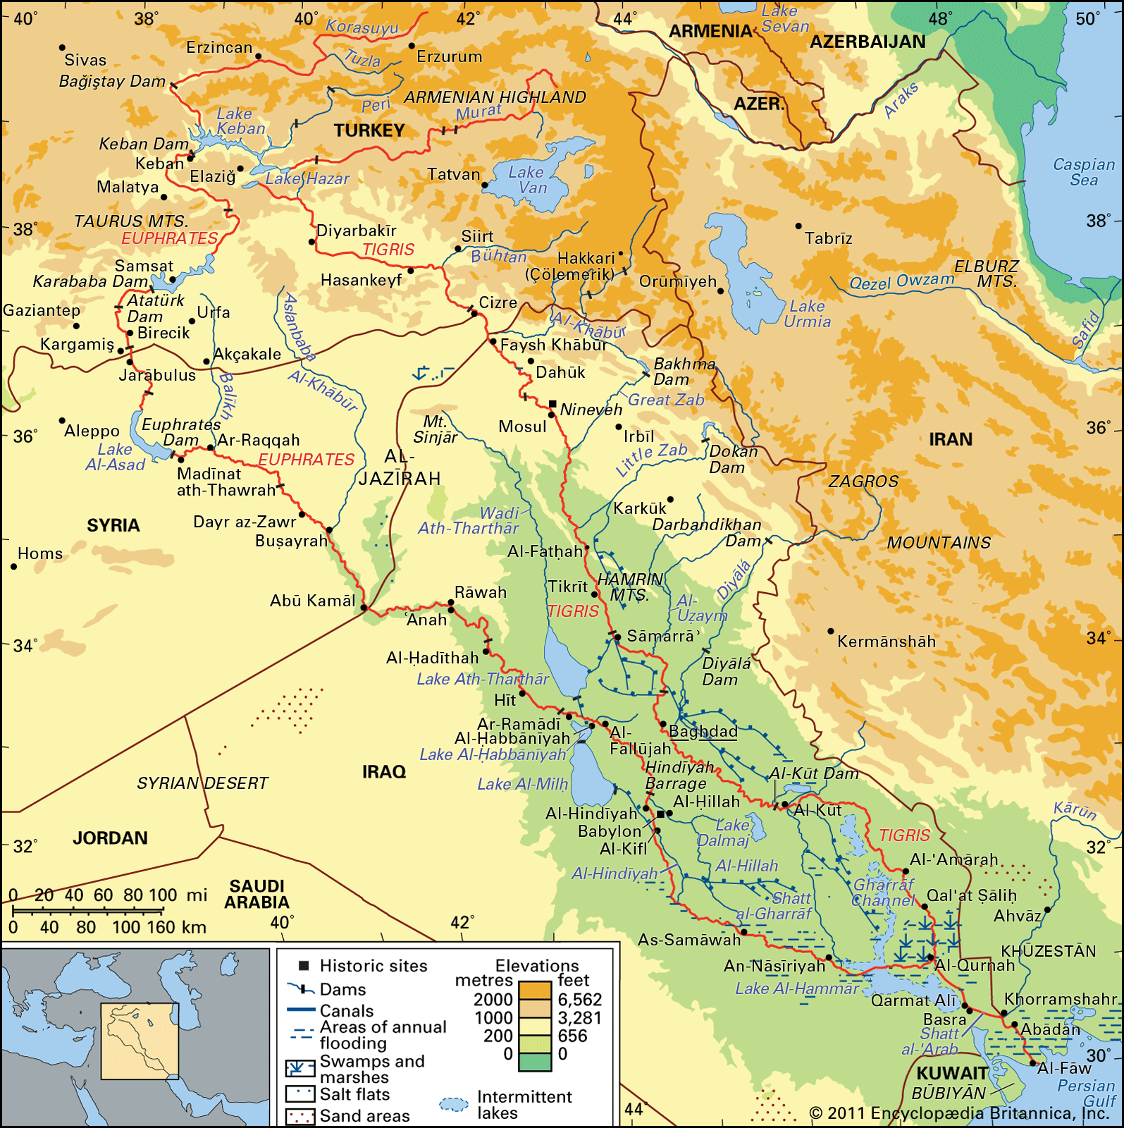 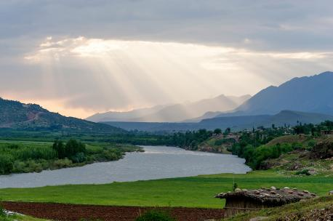

Khubar or Chibar River:

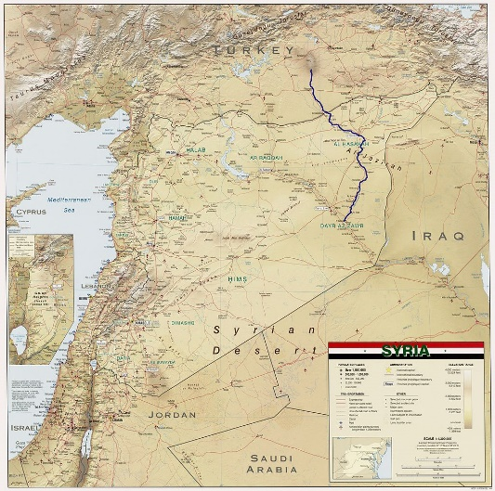 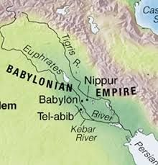

* Tarshish – Indian Ocean
  + 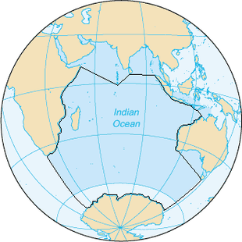 2000 Parsah ~5500miles Max.
  + Length 6,000 mi - Antarctica to Bay of Bengal, width 4,700 mi - Africa to Australia
  + Book of Yonah
  + Gems in Asher – RSG – wave crest, other, the color of the ocean
  + If every part of the body is mentioned, then how did he look like the ocean, maybe for the size
  + Linen – Matches the Cohen gadol, Michael is linen (possibly belt is as well)
  + Compare other features to prophecies in Yechezkial
* Who were the friends – Chagai, Zecharia and Malachi
  + Why, they were people who were respectable (and that is why there is a statement that they didn’t see it (Rashi?) ; or to comment that even though they were prophets that usually see even the prophecy of Hashem, they did not see this (Maharsha Sanhedrin) (add a prophet sees other prophecies, even if they are not meant for them).
  + (side of Eyn Yaakov Megilla, about heart and brain, and z”i from pasuk bilibi
  + Why not Chanania, maybe as in Sanhedrin they were in Israel, maybe because they had already seen Gavriel and would not have been scared, forgot third reason
  + Comparing to Moshe –snake, Yehoshua and Manoach when they fled, maybe it wasn’t the angel, but what this represented
  + Gemarah in Megilla about running and mazel
  + Was he a navi – Rashi in Megilla, Etz Yosef comparing to Rashi in Megilla 14, (seems from wording that Rashi was accepting both opinions) etymology of Navi, Ibn Ezra, Abarbanel
  + Seeing angels –Rashi, Rambam, ??
  + Discuss Muaf biyaaf
  + Compare to previous times that Daniel encountered Gavriel
  + Discuss the idea that Hashem is our guardian